Matthew Austin

Ethical Hacking

Yi Yang

18 February 2019

Lab 2

1. Made user: Adduser georgia
   1. Went to different account: Su john
   2. Signed into georgia account: Su georgia
      1. Entered password to login to georgia account

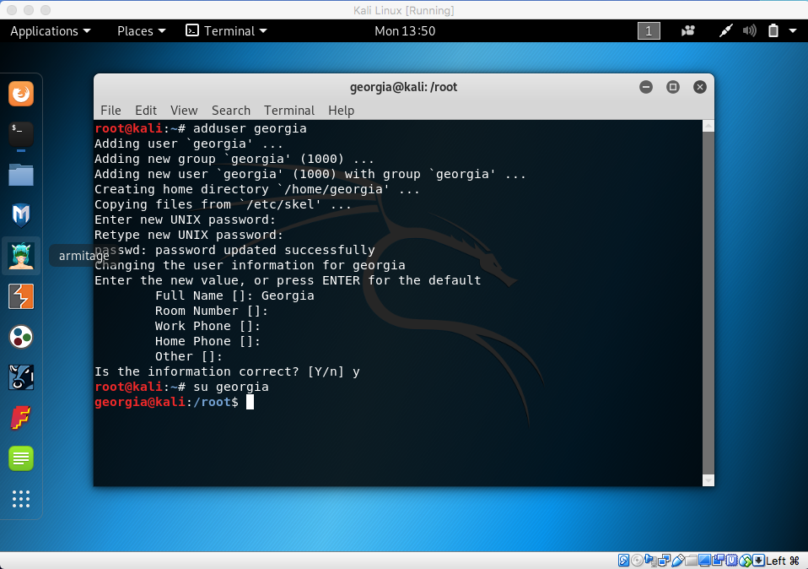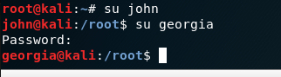

2.) Made file: touch file1

Wrote to file: Echo hello my name is matt. I am a senior at fontbonne > file 1

Viewed files contents: cat file1

Changed permission to read, write, execute for owner: chmod 700 file1 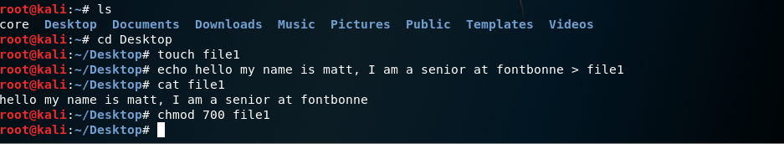

3.) Made file2: touch file 2

Retrieved all instances from keyword “fontbonne” from file 1 and output all of them into another file file2: grep fontbonne file1 | car file1 > file2

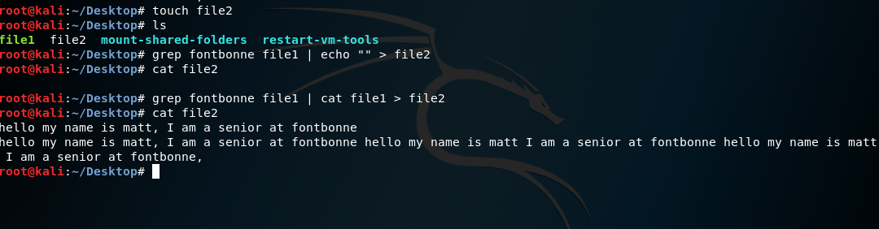

4.) used netcat to transfer file between listener and listenee: nc -lcp 60 > file1

Nc 10.0.2.15 60 < file1

Calculated the data transmission rate between these two parties: nc -lcp 60 then time yes | nc 10.0.2.15 60

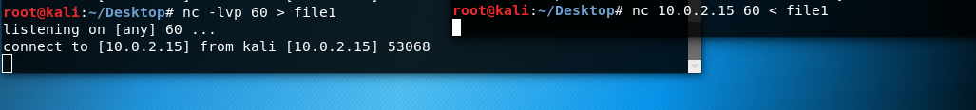

Data transmission rate is show below is show in image below

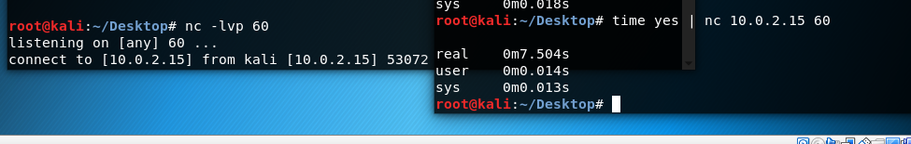

5.) edit crontab: nano /etc/crontab

Added “ls | grep cron” into crontab

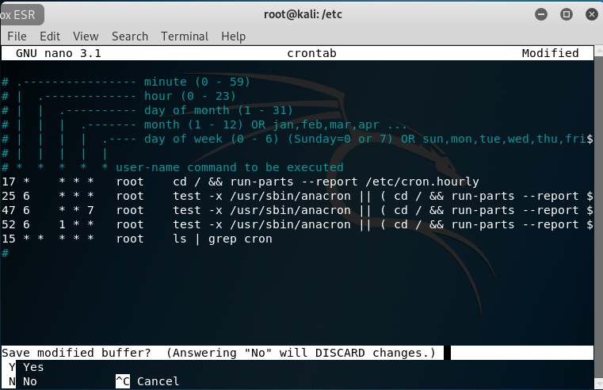

Proof that the task is running hourly

